**Assignment 3: Using Service**

**Main Activity (PickFile_Activity_Three):**

**XML FILE:**

*<?***xml version="1.0" encoding="utf-8"***?>*<**androidx.constraintlayout.widget.ConstraintLayout xmlns:android="http://schemas.android.com/apk/res/android"  
 xmlns:app="http://schemas.android.com/apk/res-auto"  
 xmlns:tools="http://schemas.android.com/tools"  
 android:layout_width="match_parent"  
 android:layout_height="match_parent"  
 android:background="#232222"  
 tools:context=".Assignment_3.PickFile_Activity_Three"**>  
  
 <**TextView  
 android:id="@+id/textView5"  
 android:layout_width="0dp"  
 android:layout_height="wrap_content"  
 android:layout_weight="1"  
 android:fontFamily="@font/kaushan_script"  
 android:text="Music"  
 android:textAlignment="center"  
 android:textColor="@color/white"  
 android:textSize="80sp"  
 android:textStyle="bold"  
 app:layout_constraintBottom_toTopOf="@+id/ConstraintLayout3"  
 app:layout_constraintEnd_toEndOf="parent"  
 app:layout_constraintHorizontal_bias="0.0"  
 app:layout_constraintStart_toStartOf="parent"  
 app:layout_constraintTop_toBottomOf="@+id/constraintLayout2"  
 app:layout_constraintVertical_bias="0.0"** />  
  
 <**androidx.constraintlayout.widget.ConstraintLayout  
 android:id="@+id/constraintLayout2"  
 android:layout_width="108dp"  
 android:layout_height="102dp"  
 android:layout_marginTop="48dp"  
 android:background="@drawable/baseline_headphones_24"  
 android:orientation="horizontal"  
 app:layout_constraintEnd_toEndOf="parent"  
 app:layout_constraintHorizontal_bias="0.498"  
 app:layout_constraintStart_toStartOf="parent"  
 app:layout_constraintTop_toTopOf="parent"  
 tools:ignore="MissingConstraints,UselessParent"**>  
  
 </**androidx.constraintlayout.widget.ConstraintLayout**>  
  
 <**androidx.constraintlayout.widget.ConstraintLayout  
 android:id="@+id/ConstraintLayout3"  
 android:layout_width="358dp"  
 android:layout_height="258dp"  
 android:layout_marginBottom="76dp"  
 android:backgroundTint="#AAA8A8"  
 android:background="@drawable/rounded_corner_background"  
 app:layout_constraintBottom_toBottomOf="parent"  
 app:layout_constraintEnd_toEndOf="parent"  
 app:layout_constraintHorizontal_bias="0.49"  
 app:layout_constraintStart_toStartOf="parent"  
 tools:ignore="ExtraText,MissingConstraints"**>  
  
 <**Button  
 android:id="@+id/Mp4Button"  
 android:layout_width="191dp"  
 android:layout_height="73dp"  
 android:layout_marginBottom="44dp"  
 android:background="#00FFFFFF"  
 android:text="PICK MP4 FILE"  
 android:textColor="@color/white"  
 android:textSize="20sp"  
 app:layout_constraintBottom_toBottomOf="parent"  
 app:layout_constraintEnd_toEndOf="parent"  
 app:layout_constraintHorizontal_bias="0.18"  
 app:layout_constraintStart_toEndOf="@+id/Video"  
 tools:ignore="TextSizeCheck"** />  
  
 <**Button  
 android:id="@+id/Mp3Button"  
 android:layout_width="191dp"  
 android:layout_height="73dp"  
 android:background="#00FFFFFF"  
 android:text="@string/pick_mp3_file"  
 android:textColor="@color/white"  
 android:textSize="20sp"  
 app:layout_constraintBottom_toTopOf="@+id/Mp4Button"  
 app:layout_constraintEnd_toEndOf="parent"  
 app:layout_constraintHorizontal_bias="0.18"  
 app:layout_constraintStart_toEndOf="@+id/Music"  
 app:layout_constraintTop_toTopOf="parent"  
 app:layout_constraintVertical_bias="0.691"  
 tools:ignore="TextSizeCheck"** />  
  
 <**Button  
 android:id="@+id/Music"  
 android:layout_width="69dp"  
 android:layout_height="72dp"  
 android:layout_marginStart="48dp"  
 android:background="@drawable/baseline_music_note_24"  
 android:contentDescription="@string/action_settings"  
 app:layout_constraintBottom_toTopOf="@+id/Video"  
 app:layout_constraintStart_toStartOf="parent"  
 app:layout_constraintTop_toTopOf="parent"  
 app:layout_constraintVertical_bias="0.685"** />  
  
 <**Button  
 android:id="@+id/Video"  
 android:layout_width="69dp"  
 android:layout_height="72dp"  
 android:layout_marginStart="48dp"  
 android:layout_marginBottom="44dp"  
 android:background="@drawable/baseline_videocam_24"  
 android:contentDescription="@string/action_settings"  
 app:layout_constraintBottom_toBottomOf="parent"  
 app:layout_constraintStart_toStartOf="parent"** />  
 </**androidx.constraintlayout.widget.ConstraintLayout**>  
  
</**androidx.constraintlayout.widget.ConstraintLayout**>

**JAVA FILE:**

**package** com.example.smd_assignments.Assignment_3;  
  
**import** androidx.annotation.Nullable;  
**import** androidx.appcompat.app.AppCompatActivity;  
  
**import** android.annotation.SuppressLint;  
**import** android.content.Intent;  
**import** android.net.Uri;  
**import** android.os.Bundle;  
**import** android.view.View;  
**import** android.widget.Button;  
  
**import** com.example.smd_assignments.R;  
  
**public class** PickFile_Activity_Three **extends** AppCompatActivity {  
  
 Button **button1**, **button2**;  
 Intent **intent**;  
  
 **public static final int *Pick_File*** = 99;  
 **public static final int *Pick_File1*** = 200;  
  
 @SuppressLint(**"MissingInflatedId"**)  
 @Override  
 **protected void** onCreate(Bundle savedInstanceState) {  
 **super**.onCreate(savedInstanceState);  
 setContentView(R.layout.***activity_pick_file_three***);  
  
 **button1** = findViewById(R.id.***Mp3Button***);  
 **button1**.setOnClickListener(**new** View.OnClickListener() {  
 @Override  
 **public void** onClick(View view) {  
 Intent intent = **new** Intent(Intent.***ACTION_OPEN_DOCUMENT***);  
 intent.addCategory(Intent.***CATEGORY_OPENABLE***);  
 intent.setType(**"audio/*"**);  
 startActivityForResult(intent, ***Pick_File***);  
 }  
 });  
  
 **button2** = findViewById(R.id.***Mp4Button***);  
 **button2**.setOnClickListener(**new** View.OnClickListener() {  
 @Override  
 **public void** onClick(View view) {  
 Intent intent1 = **new** Intent(Intent.***ACTION_OPEN_DOCUMENT***);  
 intent1.addCategory(Intent.***CATEGORY_OPENABLE***);  
 intent1.setType(**"video/*"**);  
 startActivityForResult(intent1, ***Pick_File1***);  
 }  
 });  
  
 }  
  
 @Override  
 **protected void** onActivityResult(**int** requestCode, **int** resultCode, @Nullable Intent data) {  
 **super**.onActivityResult(requestCode, resultCode, data);  
 **if**(requestCode == 99) {  
 Uri uri = data.getData();  
 PlayMusic(uri);  
 }  
 **else if**(requestCode == 200)  
 {  
 Uri uri = data.getData();  
 PlayVideo(uri);  
 }  
 }  
  
 **public void** PlayMusic(Uri uri)  
 {  
 **intent** = **new** Intent(PickFile_Activity_Three.**this**,MusicPlayer_Activity_Two.**class**);  
 **intent**.putExtra(**"Music"**, uri);  
 startActivity(**intent**);  
  
 }  
  
 **public void** PlayVideo(Uri uri)  
 {  
 **intent** = **new** Intent(PickFile_Activity_Three.**this**,MediaPlayer_Activity_One.**class**);  
 **intent**.putExtra(**"Video"**, uri);  
 startActivity(**intent**);  
 }  
}

**Output:**

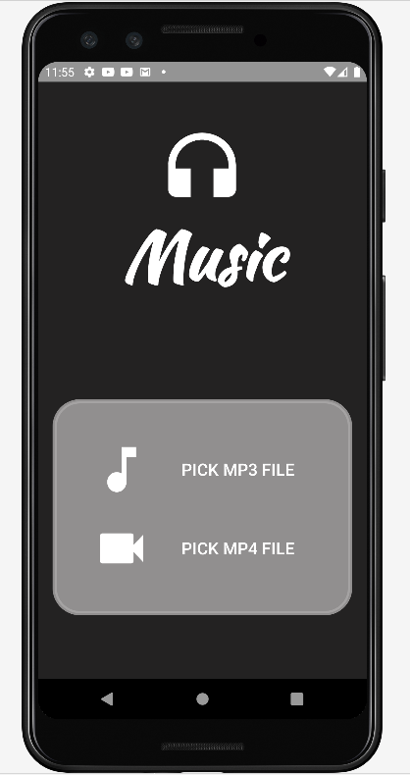

**Music Player:**

**XML FILE:**

*<?***xml version="1.0" encoding="utf-8"***?>*<**androidx.constraintlayout.widget.ConstraintLayout xmlns:android="http://schemas.android.com/apk/res/android"  
 xmlns:app="http://schemas.android.com/apk/res-auto"  
 xmlns:tools="http://schemas.android.com/tools"  
 android:layout_width="match_parent"  
 android:layout_height="match_parent"  
 android:background="#232222"  
 tools:context=".Assignment_3.MusicPlayer_Activity_Two"**>  
  
 <**Button  
 android:id="@+id/Play"  
 android:layout_width="69dp"  
 android:layout_height="72dp"  
 android:background="@drawable/baseline_play_arrow_24"  
 android:contentDescription="@string/action_settings"  
 app:layout_constraintBottom_toBottomOf="parent"  
 app:layout_constraintEnd_toEndOf="parent"  
 app:layout_constraintStart_toStartOf="parent"  
 app:layout_constraintTop_toTopOf="parent"  
 app:layout_constraintVertical_bias="0.86"** />  
  
 <**Button  
 android:id="@+id/forward"  
 android:layout_width="69dp"  
 android:layout_height="72dp"  
 android:background="@drawable/baseline_arrow_forward_ios_24"  
 android:contentDescription="@string/action_settings"  
 app:layout_constraintBottom_toBottomOf="parent"  
 app:layout_constraintEnd_toEndOf="parent"  
 app:layout_constraintHorizontal_bias="0.804"  
 app:layout_constraintStart_toStartOf="parent"  
 app:layout_constraintTop_toTopOf="parent"  
 app:layout_constraintVertical_bias="0.86"** />  
  
 <**Button  
 android:id="@+id/backward"  
 android:layout_width="69dp"  
 android:layout_height="72dp"  
 android:background="@drawable/baseline_arrow_back_ios_24"  
 android:contentDescription="@string/action_settings"  
 app:layout_constraintBottom_toBottomOf="parent"  
 app:layout_constraintEnd_toEndOf="parent"  
 app:layout_constraintHorizontal_bias="0.245"  
 app:layout_constraintStart_toStartOf="parent"  
 app:layout_constraintTop_toTopOf="parent"  
 app:layout_constraintVertical_bias="0.86"** />  
  
 <**Button  
 android:id="@+id/Stop"  
 android:layout_width="62dp"  
 android:layout_height="68dp"  
 android:background="#232222"  
 android:contentDescription="@string/action_settings"  
 android:drawableTop="@drawable/baseline_stop_24"  
 app:layout_constraintBottom_toBottomOf="parent"  
 app:layout_constraintStart_toEndOf="@+id/seekBar"  
 app:layout_constraintTop_toTopOf="parent"  
 app:layout_constraintVertical_bias="0.723"** />  
  
 <**SeekBar  
 android:id="@+id/seekBar"  
 android:layout_width="269dp"  
 android:layout_height="55dp"  
 android:progressBackgroundTint="#54AEF1"  
 android:secondaryProgressTint="@color/white"  
 android:thumbTint="#5B46FE"  
 app:layout_constraintBottom_toTopOf="@+id/Play"  
 app:layout_constraintEnd_toEndOf="parent"  
 app:layout_constraintHorizontal_bias="0.211"  
 app:layout_constraintStart_toStartOf="parent"  
 app:layout_constraintTop_toTopOf="parent"  
 app:layout_constraintVertical_bias="0.937"  
 tools:ignore="MissingConstraints"** />  
  
 <**ImageView  
 android:id="@+id/image"  
 android:layout_width="326dp"  
 android:layout_height="326dp"  
 android:contentDescription="@string/todo"  
 android:src="@drawable/image4"  
 app:layout_constraintBottom_toTopOf="@+id/name"  
 app:layout_constraintEnd_toEndOf="parent"  
 app:layout_constraintHorizontal_bias="0.494"  
 app:layout_constraintStart_toStartOf="parent"  
 app:layout_constraintTop_toTopOf="parent"  
 app:layout_constraintVertical_bias="0.753"** />  
  
 <**TextView  
 android:id="@+id/name"  
 android:layout_width="305dp"  
 android:layout_height="49dp"  
 android:layout_marginBottom="28dp"  
 android:text="Music Player"  
 android:textAlignment="center"  
 android:textColor="@color/white"  
 android:textSize="25sp"  
 app:layout_constraintBottom_toTopOf="@+id/seekBar"  
 app:layout_constraintEnd_toEndOf="parent"  
 app:layout_constraintStart_toStartOf="parent"  
 tools:ignore="TextSizeCheck"** />  
</**androidx.constraintlayout.widget.ConstraintLayout**>

**JAVA FILE:**

**package** com.example.smd_assignments.Assignment_3;  
  
**import** androidx.appcompat.app.AppCompatActivity;  
  
**import** android.annotation.SuppressLint;  
**import** android.content.Intent;  
**import** android.media.AudioManager;  
**import** android.media.MediaPlayer;  
**import** android.net.Uri;  
**import** android.os.Bundle;  
**import** android.os.Handler;  
**import** android.view.View;  
**import** android.widget.Button;  
**import** android.widget.SeekBar;  
**import** android.widget.Toast;  
  
**import** com.example.smd_assignments.R;  
  
**import** java.io.IOException;  
  
**public class** MusicPlayer_Activity_Two **extends** AppCompatActivity {  
 MediaPlayer **mediaPlayer**;  
 @SuppressLint(**"MissingInflatedId"**)  
 @Override  
 **protected void** onCreate(Bundle savedInstanceState) {  
 **super**.onCreate(savedInstanceState);  
 setContentView(R.layout.***activity_music_player_two***);  
  
 Button btnPlay, btnStop, btnforward, btnbackward;  
  
 btnPlay = findViewById(R.id.***Play***);  
 btnStop = findViewById(R.id.***Stop***);  
 btnbackward = findViewById(R.id.***backward***);  
 btnforward = findViewById(R.id.***forward***);  
  
  
 MediaPlayer mediaPlayer = **new** MediaPlayer();  
  
 mediaPlayer.setAudioStreamType(AudioManager.***STREAM_MUSIC***);  
  
 Intent intent1 = getIntent();  
  
 Uri AudioUri = (Uri) intent1.getParcelableExtra(**"Music"**);  
  
 **try** {  
 mediaPlayer.setDataSource(**this**, AudioUri);  
 mediaPlayer.prepare();  
 } **catch** (IOException e) {  
 **throw new** RuntimeException(e);  
 }  
  
  
 btnPlay.setOnClickListener(**new** View.OnClickListener() {  
 @SuppressLint(**"ResourceAsColor"**)  
 @Override  
 **public void** onClick(View view) {  
 **if**(mediaPlayer.isPlaying())  
 {  
 btnPlay.setBackgroundResource(R.drawable.***baseline_play_arrow_24***);  
 mediaPlayer.pause();  
 }  
 **else** {  
 btnPlay.setBackgroundResource(R.drawable.***baseline_pause_24***);  
 mediaPlayer.start();  
 }  
 }  
 });  
  
  
 btnStop.setOnClickListener(**new** View.OnClickListener() {  
 @Override  
 **public void** onClick(View view) {  
 mediaPlayer.pause();  
 mediaPlayer.seekTo(0);  
 }  
 });  
  
 btnforward.setOnClickListener(**new** View.OnClickListener() {  
 @Override  
 **public void** onClick(View view) {  
 **if**(mediaPlayer.isPlaying())  
 {  
 mediaPlayer.seekTo(mediaPlayer.getCurrentPosition()+10000);  
 }  
 }  
 });  
  
 btnbackward.setOnClickListener(**new** View.OnClickListener() {  
 @Override  
 **public void** onClick(View view) {  
 **if**(mediaPlayer.isPlaying())  
 {  
 mediaPlayer.seekTo(mediaPlayer.getCurrentPosition()-10000);  
 }  
 }  
 });  
 }  
}

**Output:**

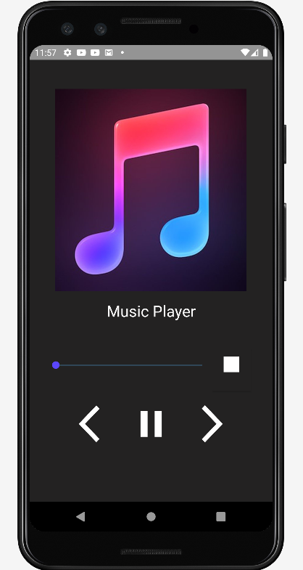

**Video Player:**

**XML FILE:**

*<?***xml version="1.0" encoding="utf-8"***?>*<**androidx.constraintlayout.widget.ConstraintLayout xmlns:android="http://schemas.android.com/apk/res/android"  
 xmlns:app="http://schemas.android.com/apk/res-auto"  
 xmlns:tools="http://schemas.android.com/tools"  
 android:id="@+id/linearLayout2"  
 android:layout_width="match_parent"  
 android:layout_height="match_parent"  
 android:background="@color/black"  
 tools:context=".Assignment_3.MediaPlayer_Activity_One"**>  
  
  
 <**VideoView  
 android:id="@+id/videoview1"  
 android:layout_width="wrap_content"  
 android:layout_height="300dp"  
 app:layout_constraintBottom_toBottomOf="parent"  
 app:layout_constraintStart_toStartOf="parent"  
 app:layout_constraintTop_toTopOf="parent"  
 app:layout_constraintVertical_bias="0.498"** />  
</**androidx.constraintlayout.widget.ConstraintLayout**>

**JAVA FILE:**

**package** com.example.smd_assignments.Assignment_3;  
  
**import** androidx.appcompat.app.AppCompatActivity;  
  
**import** android.content.Intent;  
**import** android.media.MediaPlayer;  
**import** android.net.Uri;  
**import** android.os.Bundle;  
**import** android.widget.MediaController;  
**import** android.widget.VideoView;  
  
**import** com.example.smd_assignments.R;  
  
**public class** MediaPlayer_Activity_One **extends** AppCompatActivity {  
  
 @Override  
 **protected void** onCreate(Bundle savedInstanceState) {  
 **super**.onCreate(savedInstanceState);  
 setContentView(R.layout.***activity_media_player_one***);  
  
 VideoView videoView = findViewById(R.id.***videoview1***);  
  
 Intent intent1 = getIntent();  
  
 Uri videouri = (Uri) intent1.getParcelableExtra(**"Video"**);  
  
 videoView.setVideoURI(videouri);  
 videoView.start();  
  
 MediaController mediaController = **new** MediaController(**this**);  
 videoView.setMediaController(mediaController);  
 mediaController.setAnchorView(videoView);  
  
  
 }  
}

**Output:**

